UBS

System Design Document
Of
UBS Multibanking System
07-MAY-2012
Version 1.0

Submitted by





TCS Hyderabad,

Serlingampally, Hyderabad-32.
May 2012

DOCUMENT RELEASE NOTICE

Document Details:

Name | Version No. | Description
Design Documentation | 1.0 | This contains the brief description of the design part.

Revision Details

Action taken  (Add / Del / Chg) | Preceding page no. | New page no. | Revision description

Review:
Reviewer | Date

Approval:
Approver | Date

Abbreviations :

Abbreviation | Meaning

Contents

1 Detailed Design 5
1.1 USER PROFILES 5
1.1.1 USER PROFILES Functionality: 5
1.1.2 High level Design of USER PROFILES 5
1.1.2.1 Class Diagrams 5
1.1.2.2 Sequence Diagrams 5
1.1.3 Data Model of USER PROFILES 8
1.1.3.1 table_ Customer_Profile 8
1.1.3.2 table_Login 8
1.2 Ticket Creation 9
1.2.1 Ticket Creation Functionality: 9
1.2.2 High level Design of Ticket Creation 9
1.2.2.1 Class Diagrams 9
1.2.2.2 Sequence Diagrams 9
1.2.3 Data Model of Ticket Creation 12
1.2.3.1 table_ Ticket_Ttms 12
1.2.3.2 table_ Prob_Categ 12
1.3 Ticket Management 13
1.3.1 Ticket Management Functionality: 13
1.3.2 High level Design of Ticket management 13
1.3.2.1 Class Diagrams 13
1.3.2.2 Sequence Diagrams 13
1.3.3 Data Model of Ticket Management 16
1.3.3.1 table_ Ticket_Ttms 16
2.1 Domain Diagram for whole project 17
2.2 Class Diagram for whole project 18
3 Glossary 19

Detailed Design

Payee PROFILES

Payee PROFILES Functionality:
This module helps customer add an payee details in the multibanking system and also facilitates the customer to update/view/delete add payee profile.

High level Design of Payee PROFILES

Class Diagrams
- One Consolidated Class diagram for Customer will be provided.
- Class Diagram will cover classes defined for core layers comprising of Service, BO and Data Access.
- Customer is the actor in Sequence Diagrams.

Sequence Diagrams
- Sequence diagram will be provided for this module in the following pages.
Description :in this diagram, the customer logins after the successful validation and verification.
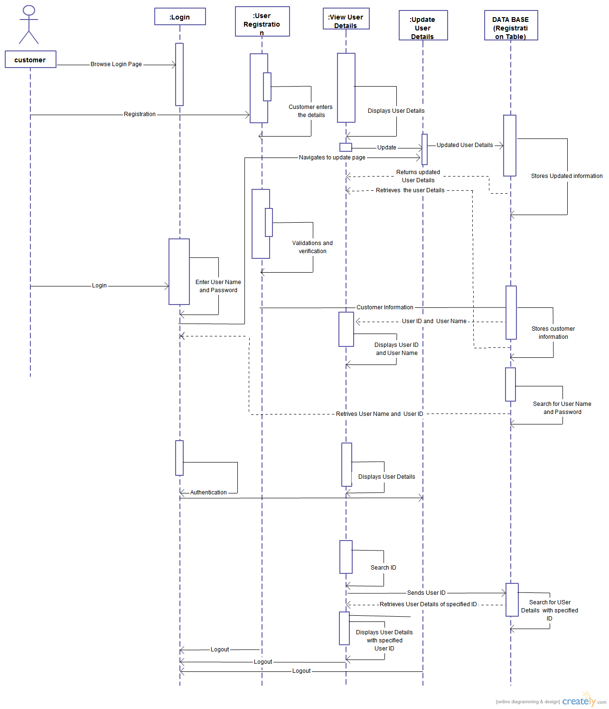

Description : In this diagram, the customer can add the payee details. After the validation and verification the details will saved in the database.
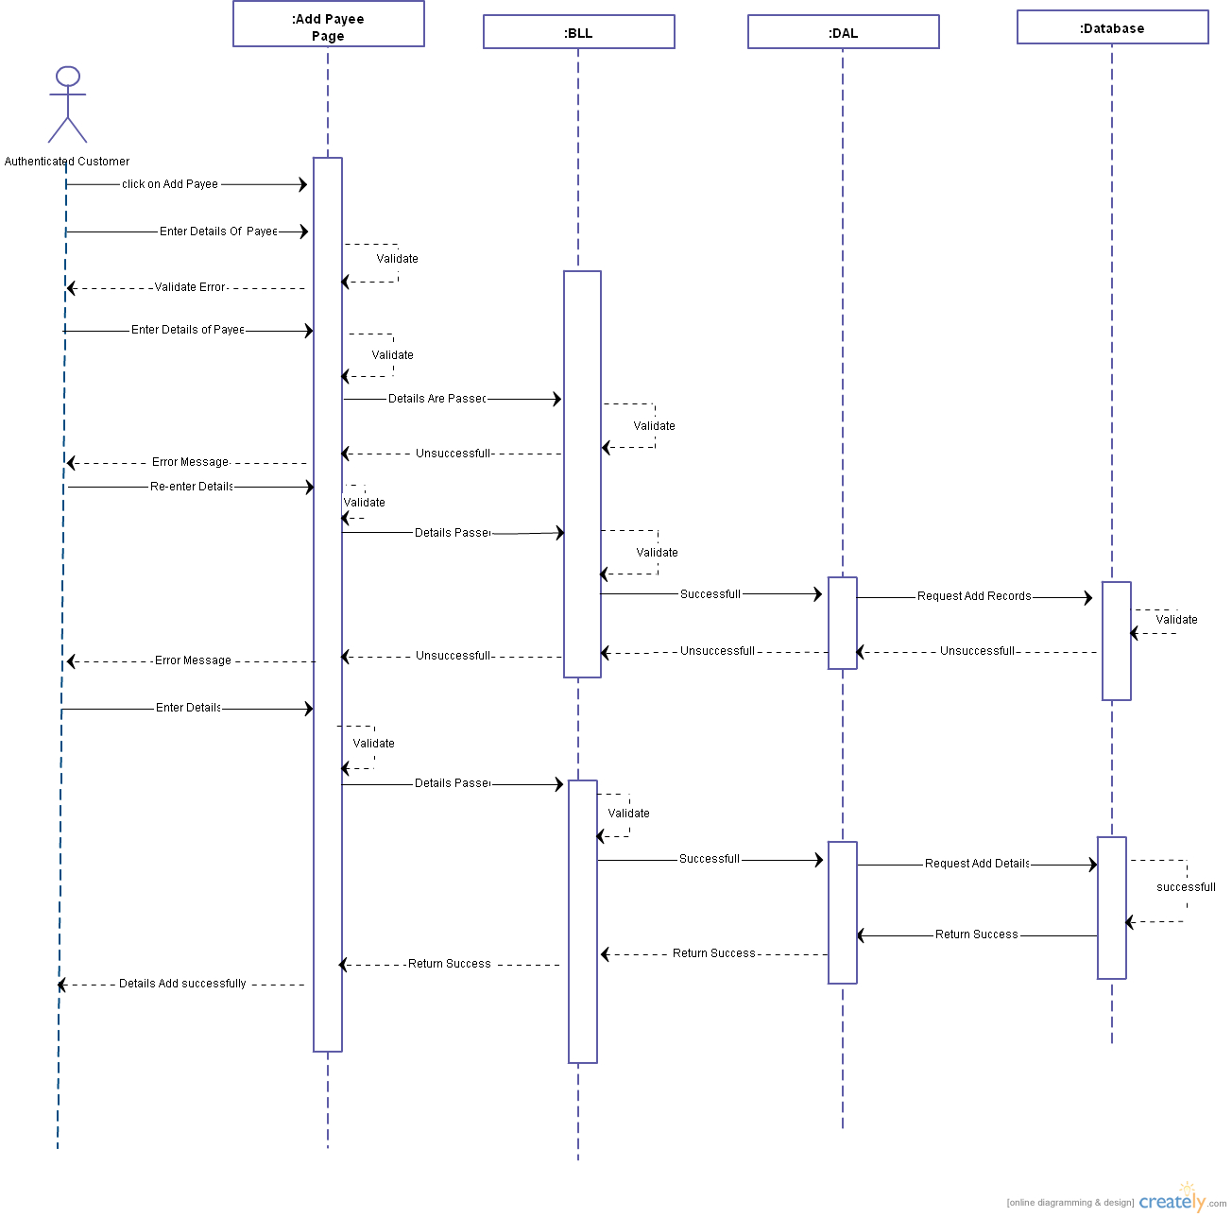

Description :in this diagram, the customer the view the details of the added payee and its status.
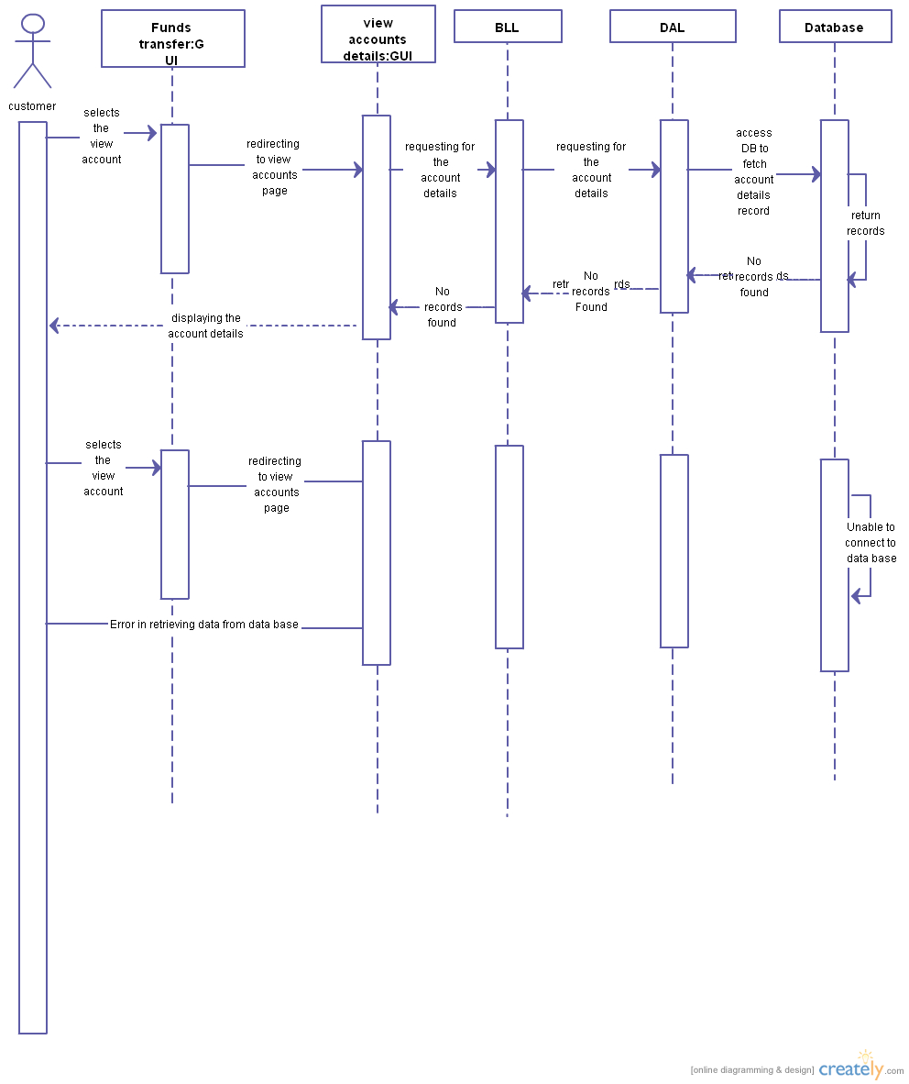

Description :in this diagram, the customer can update details of the added payee. After the validation the modified details will be saved.

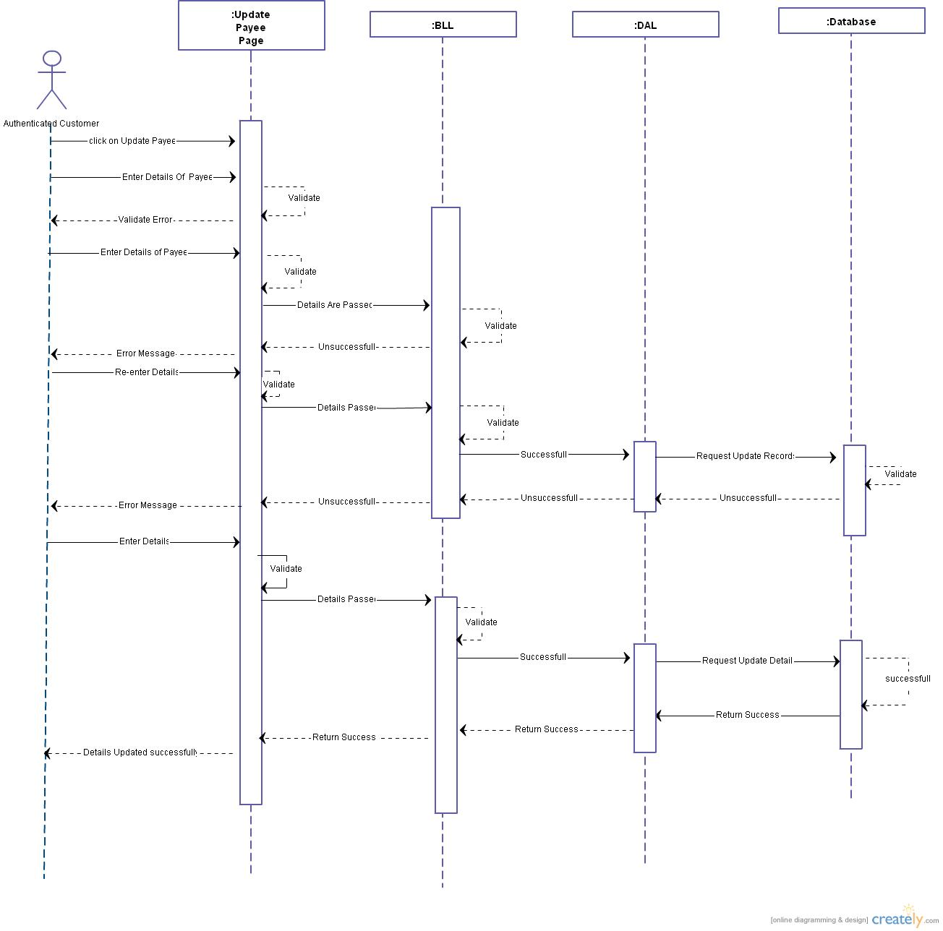

Description :in this diagram, the customer can delete details of the added payee. After the validation the details will be delete.
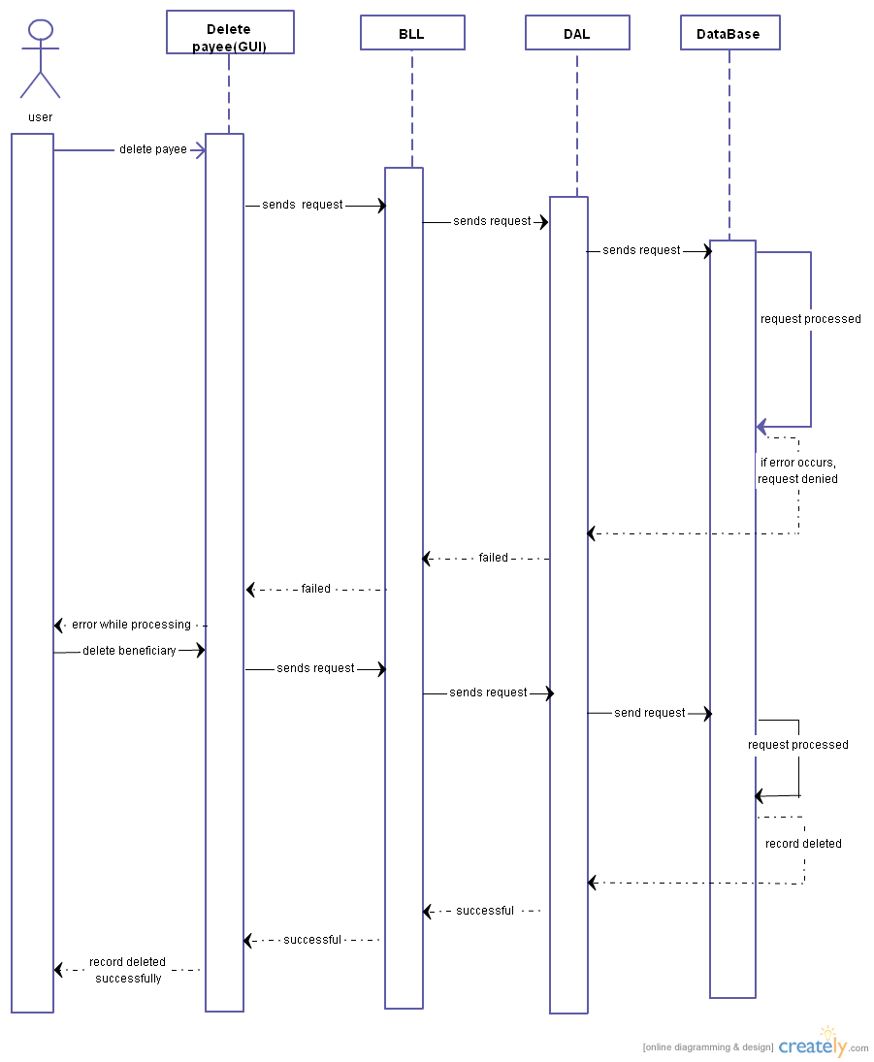

Data Model of USER PROFILES

1.1.3.1 table_Login
Brief Description:
This table consists of the Login details.
Attributes:
S.No | Attribute Name | Data type | Null | Remarks
1 | userId | varchar(30) | No | Primarykey  Unique Id of User.
2 | pwd | varchar(50) | No | Password stored for specified userid.
3 | roleId | varchar(20) | No | Customer/Agent.
4 | transaction_passwrod | varchar(10) | No | To store the transaction password
5 | IsChanged | Bit | No | To indicate whether transaction password is changed or not.

      - tblPayeeDetails
Description: this table consists of Payee Details
Attributes:
Sr.no | Attributes | Datatype | Nullable | Remark
1. | PayeeAccNo | Numeric | No | Primary key.  To store account number of the payee.
2. | PayeeName | Varchar(20) | No | To store name of the payee.
3 | CustomerId | numeric | No | Foreign key
3. | PBankName | Varchar(30) | No | To store bank nameof the payee’s account.
4. | PBranchName | Varchar(30) | No | To store branch name of the payee’s account.
5. | IfscCode | Varchar(30) | No
6. | EmailId | Varchar(30) | Yes | To store email address of the payee
7. | PayeeType | Varchar (20) | No | check constraint to check payeetype in self,third party
8. | RequestId | numeric | No | To store status of the payee account. Foreign key of table  tblRequest(RequestId)

Funds Transfer

Funds Transfer Functionality:
This module helps customer to transfer funds to his own account or to added payee account.

High level Design of Funds Transfer

Class Diagrams
- One Consolidated Class diagram for funds Transfer will be provided.
- Class Diagram will cover classes defined for core layers comprising of Service, BO and Data Access.
- Customer is the actor in the Sequence Diagram.

Sequence Diagrams
Description : in this diagram, the customer the can transfers funds to his own account or to added payee's account. After the validation and verification the funds will be transferred.

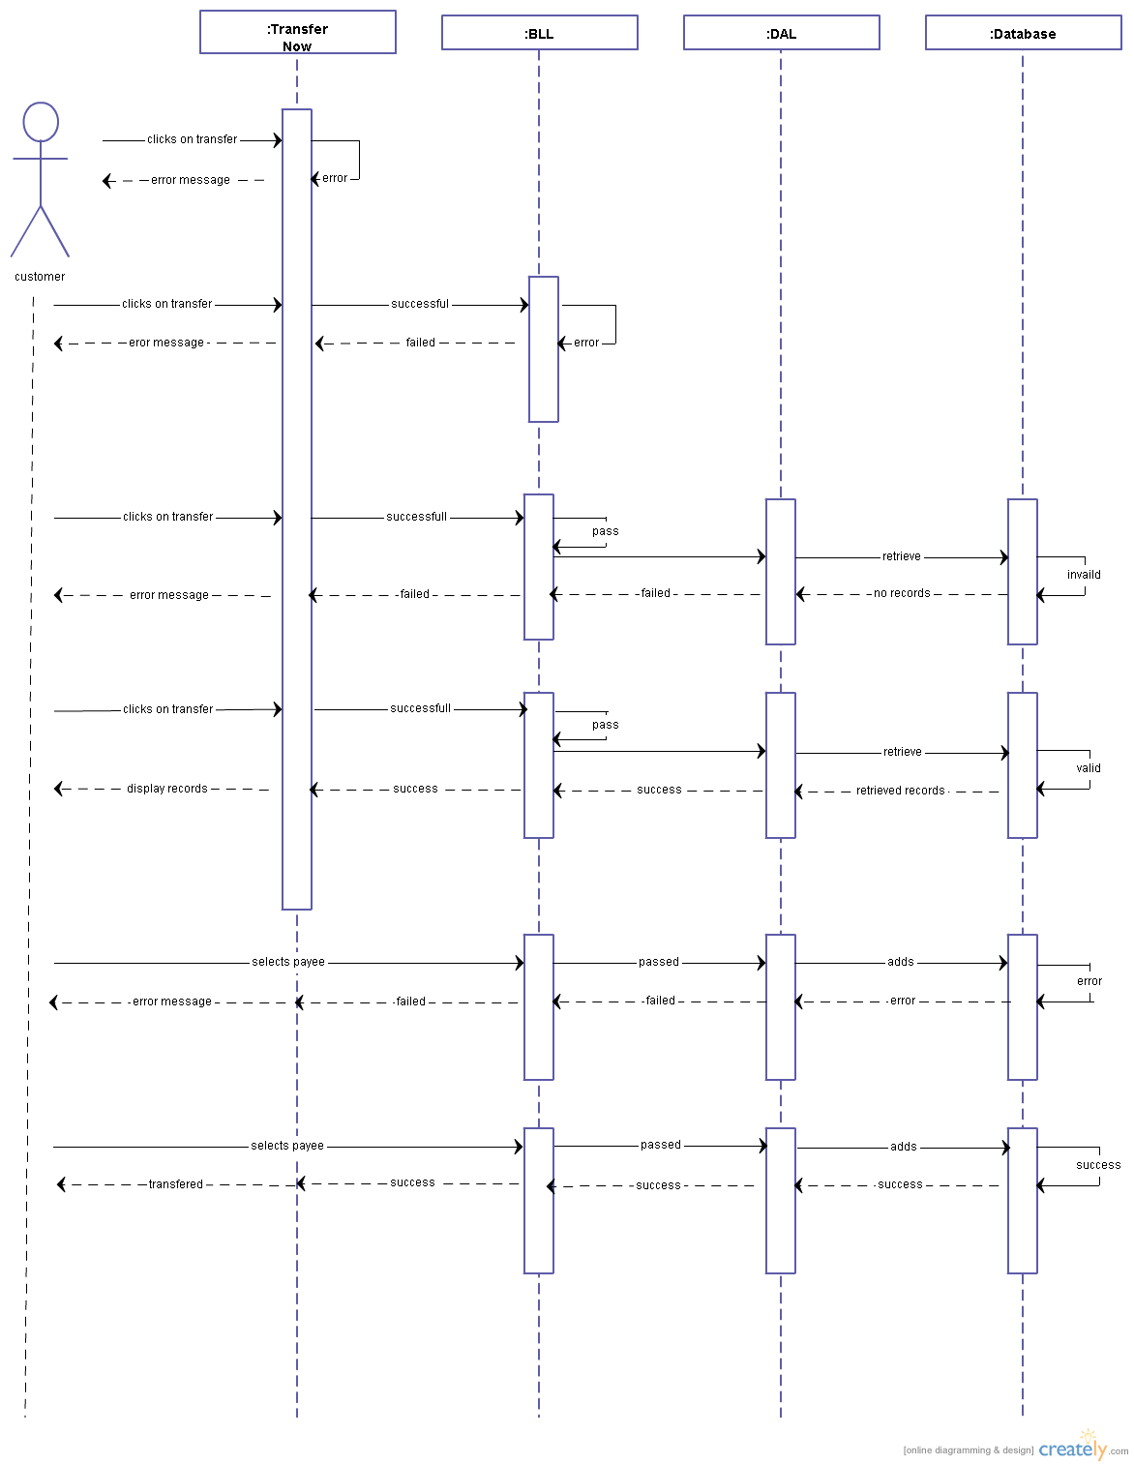

Data Model of Funds Transfer

tblFundsTransferred

Brief Description:
This table consists of the transferred funds details.
Attributes:

Sr.no | Attributes | Datatype | Nullable | Remarks
1. | TransferId | Varchar(10) | No | Primary key
2. | CustomerId | Varchar(10) | No | Foreign key of tblCustomer(CustomerID). To store the customer id.
3. | CustomerAccNo | Numeric | No | Foreign key of Account(AccountNo).  To store the account number of the customer.
4. | PayeeAccNo | Numeric | No | To store account number of the payee.
5. | TransferDatetime | Datetime | No | To store date and time of transfer.
6. | Amount | Money | No | To store amount to be transferred.
7. | TransferStatus | Varchar(20) | No | To store the status of the transfer. Should be either ‘Successful’ or ‘Failed’.

Request Management

Request Management Functionality:
This module helps admin to address the request to add a payee account. The admin views the dtails and verifies it. Based on the validation the admin approves/rejects the request.

High level Design of Request management

Class Diagrams
- One Consolidated Class diagram for Admin will be provided.
- Class Diagram will cover classes defined for core layers comprising of Service, BO and Data Access.
- Admin is the actor in Sequence Diagrams.

Sequence Diagrams
Description: in this diagram, the admin views the pending request of adding a payee. Based on validation and verification, the admins accepts/rejects the request.
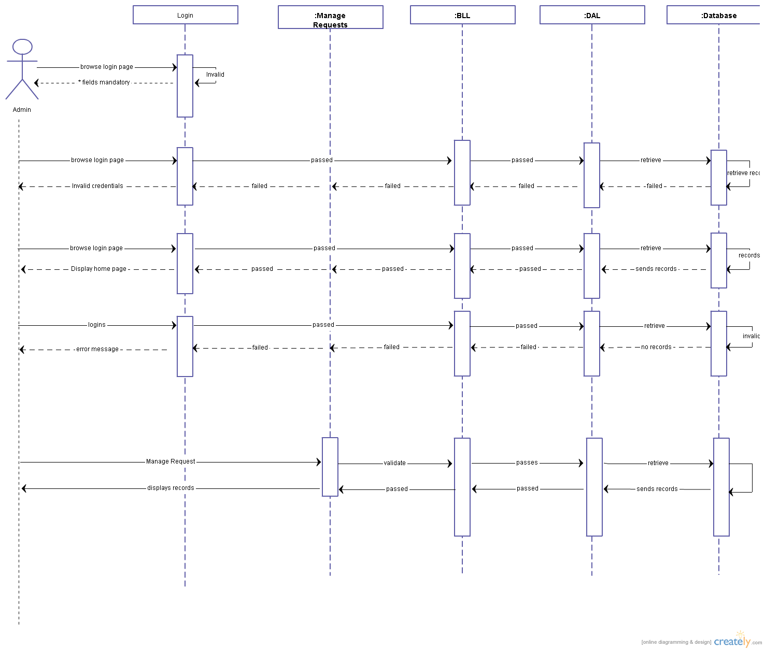

Data Model of Admin Management

tblPayeeDetails

Brief Description:
This table consists of the Payee details.
Attributes:

Sr.no | Attributes | Datatype | Nullable | Remark
1. | PayeeAccNo | Numeric | No | Primary key.  To store account number of the payee.
2. | PayeeName | Varchar(20) | No | To store name of the payee.
3 | CustomerId | numeric | No | Foreign key
3. | PBankName | Varchar(30) | No | To store bank nameof the payee’s account.
4. | PBranchName | Varchar(30) | No | To store branch name of the payee’s account.
5. | IfscCode | Varchar(30) | No | To store IFSC code.
6. | EmailId | Varchar(30) | Yes | To store email address of the payee
7. | PayeeType | Varchar (20) | No | check constraint to check payeetype in self,third party
8. | RequestId | numeric | No | To store status of the payee account. Foreign key of table  tblRequest(RequestId)

2.1 Domain Diagram for whole project

This is the domain diagram for this project . Customer will add payee's account. Admin will accept /rejects the request of the customer to add payee to their account. The customer will transfers funds to his own account or to the added and accepted payee's account.

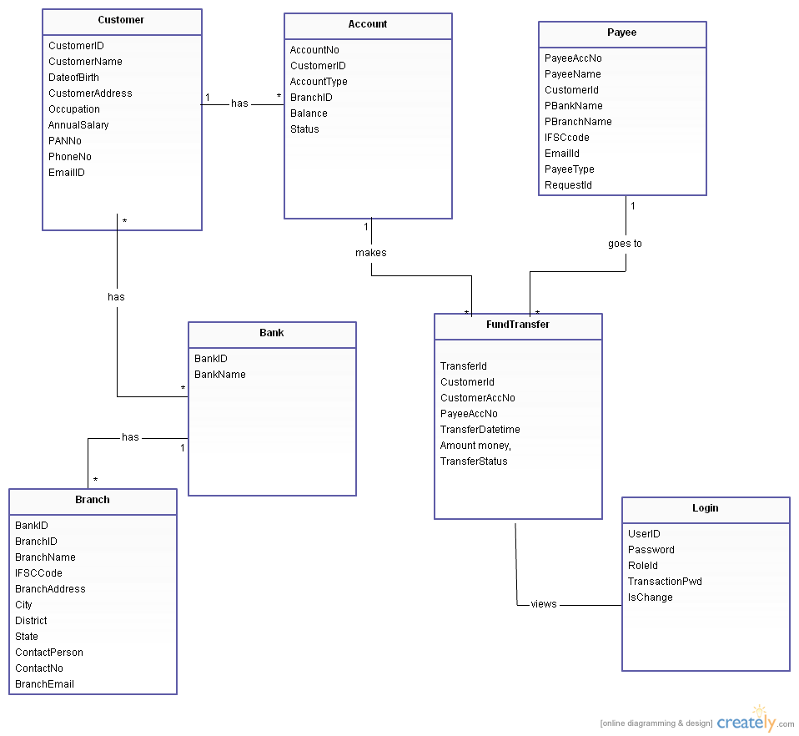

2.2 Class Diagram for whole project
These are the major different classes used in this project .Customer class is for storing customer profile details and for performing various tasks. Similarly, Funds Transfer properties are stored in the funds transfer class.
There is one to many relationship between Customer and FundTransfer & Many to one relationship between FundsTransfer and Admin.

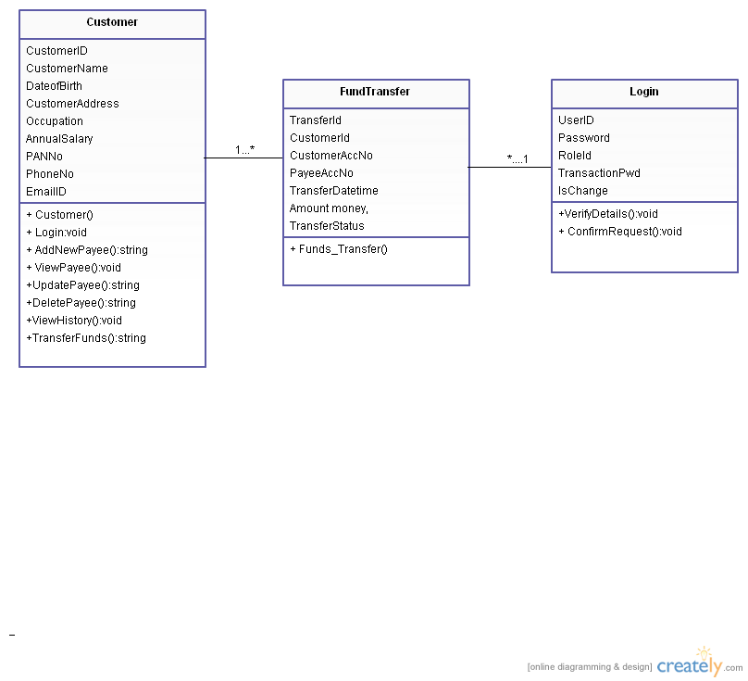

3 Glossary

Glossary Item | Glossary Item Description.
UBS | United Banking Services
Customer | The basic user/customer of the company.
Payee | The person to whom the customer wants to transfer funds
Agent | The company employee addressing the Request

